Payment Gateway
# Source: AI Source: Provided by: [Data Path: Persons Table -> ID Column: 1, Name_En Column: Motasem Essam] -> From: [ChatGPT] on [1/21/2026]
A Payment Gateway is a secure bridge that connects your website or app to the banking system, enabling electronic payments to be authorized and processed. It is a critical component for accepting online or in-app payments.

🧠 Simple Definition
# Source: AI Source: Provided by: [Data Path: Persons Table -> ID Column: 1, Name_En Column: Motasem Essam] -> From: [ChatGPT] on [1/21/2026]
A payment gateway securely captures and transmits payment data from the customer (payer) to the payment processor or bank, and returns the transaction result to your app.

📦 What a Payment Gateway Does
# Source: AI Source: Provided by: [Data Path: Persons Table -> ID Column: 1, Name_En Column: Motasem Essam] -> From: [ChatGPT] on [1/21/2026]
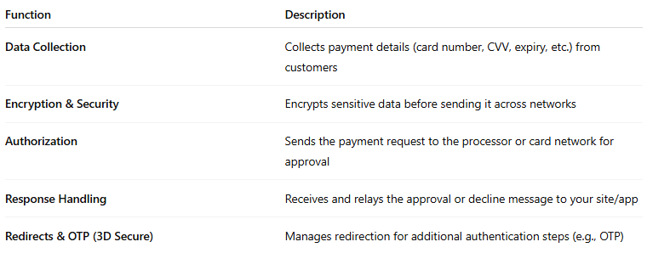

Function | Description
Data Collection | Collects payment details (card number, CVV, expiry, etc.) from customers
Encryption & Security | Encrypts sensitive data before sending it across networks
Authorization | Sends the payment request to the processor or card network for approval
Response Handling | Receives and relays the approval or decline message to your site/app
Redirects & OTP (3D Secure) | Manages redirection for additional authentication steps (e.g., OTP)

🔄 How It Fits in the Payment Flow
# Source: AI Source: Provided by: [Data Path: Persons Table -> ID Column: 1, Name_En Column: Motasem Essam] -> From: [ChatGPT] on [1/21/2026]
- User fills payment form on your site (e.g., credit card).
- Payment data is securely sent to the payment gateway.
- Gateway forwards request to the payment processor (or directly to bank).
- Processor routes it to the card network and issuing bank.
- Issuing bank approves or declines the payment.
- Response is returned through the gateway to your app (success/failure).

🧩 Payment Gateway vs. Payment Processor
# Source: AI Source: Provided by: [Data Path: Persons Table -> ID Column: 1, Name_En Column: Motasem Essam] -> From: [ChatGPT] on [1/21/2026]
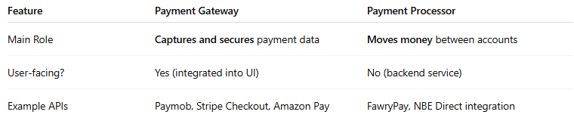

Feature | Payment Gateway | Payment Processor
Main Role | Captures and secures payment data | Moves money between accounts
User-facing? | Yes (integrated into UI) | No (backend service)
Example APIs | Paymob, Stripe Checkout, Amazon Pay | FawryPay, NBE Direct integration
Think of the gateway as the “front door” and the processor as the “delivery service”.

🔐 Security Features of a Payment Gateway
# Source: AI Source: Provided by: [Data Path: Persons Table -> ID Column: 1, Name_En Column: Motasem Essam] -> From: [ChatGPT] on [1/21/2026]
- PCI DSS Compliance (Payment Card Industry Data Security Standard)
- Tokenization (converts card data to secure tokens)
- TLS/SSL Encryption (ensures secure transmission)
- 3D Secure Authentication (OTP or biometric via bank)

📱 Types of Payment Gateway Interfaces
# Source: AI Source: Provided by: [Data Path: Persons Table -> ID Column: 1, Name_En Column: Motasem Essam] -> From: [ChatGPT] on [1/21/2026]
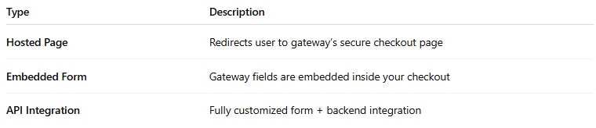

Type | Description
Hosted Page | Redirects user to gateway’s secure checkout page
Embedded Form | Gateway fields are embedded inside your checkout
API Integration | Fully customized form + backend integration

✅ Benefits of Using a Payment Gateway
# Source: AI Source: Provided by: [Data Path: Persons Table -> ID Column: 1, Name_En Column: Motasem Essam] -> From: [ChatGPT] on [1/21/2026]
- Keeps you PCI compliant by offloading sensitive data
- Offers fraud prevention tools
- Works with multiple payment methods (cards, wallets, etc.)
- Provides faster and safer checkout experiences

🔍 Popular Payment Gateway Examples
# Source: AI Source: Provided by: [Data Path: Persons Table -> ID Column: 1, Name_En Column: Motasem Essam] -> From: [ChatGPT] on [1/21/2026]
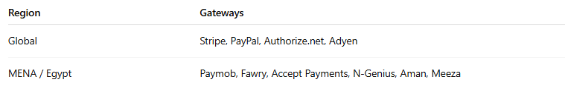

Region | Gateways
Global | Stripe, PayPal, Authorize.net, Adyen
MENA / Egypt | Paymob, Fawry, Accept Payments, N-Genius, Aman, Meeza

🧠 Summary
# Source: AI Source: Provided by: [Data Path: Persons Table -> ID Column: 1, Name_En Column: Motasem Essam] -> From: [ChatGPT] on [1/21/2026]


Component | Payment Gateway
Role | Securely sends payment info to processor/bank
Works with | Websites, apps, POS systems
Key benefit | Handles security, authorization, and feedback
Needed for | Online payments, mobile apps, e-commerce

